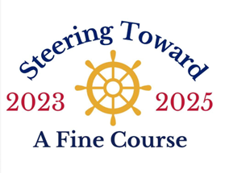

August 16-18, 2024

RENDEZVOUS AGENDA

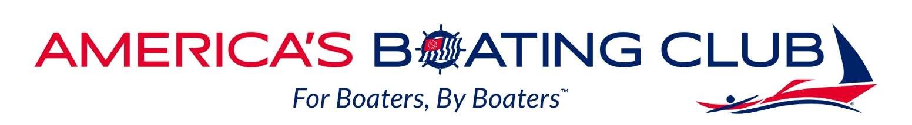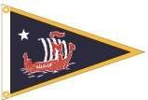

|  |  |  |
| --- | --- | --- |
| **FRIDAY EVENING AUGUST 16** | | |
| 4:00 pm 🡪 | Rendezvous Hotel  AmericInn by Wyndham  570 Pond Promenade  Chanhassen, MN 55317 | $131 King - $141 Queens per night  (through July 1 cut off)  Includes breakfast  Guest docks and camping available on island |
| 5;00 – 5:15 p  5:30 – 8:30 p | PARADISE CRUISE – BOARDING  3 hour dinner cruise on Lake Minnetonka  Tropical Appetizer Party  Cash Bar | Check-in Excelsior Bay Docks  $85 per person (est w/ 50 people) |
| **SATURDAY MORNING AUGUST 17** | | ACTIVITIES ON BIG ISLAND |
| 9:00 am | Periodic shuttle boats from Excelsior Docks to Streeter Cover on Big Island  Coffee & Donuts | No charge |
| noon | Picnic Lunch  Jimmy John’s sandwiches, pickle, chips & cookies - Lemonade | $15 per person (est) |
| 1:30 pm | Historic Walking Tour of Big Island led by Kevin Wehrmann  Horseshoes, Frisbee Golf, Volleyball, Cribbage Tournament, Swimming, Fishing | No charge |
| 5:00 – 6:30 pm | Divine Swine Pig Roast with all the fixin’s  Pork, chicken, beans, cole slaw, corn bread  Dessert bars | $35 per person |
| 6:30 – 8:30 | Campfire/socializing |  |
| 8:30 pm | Last shuttles back to Excelsior Docks |  |
| **SUNDAY MORNING AUGUST 18** | |  |
| 8:00 am | Periodic Shuttles to Big Island  Pancake Breakfast with sausages & OJ | $10 per person |